Appendix A
Technical Drawings
Figure A1
Gathered Faux Button-Up With 3/4 Sleeve Technical Drawing
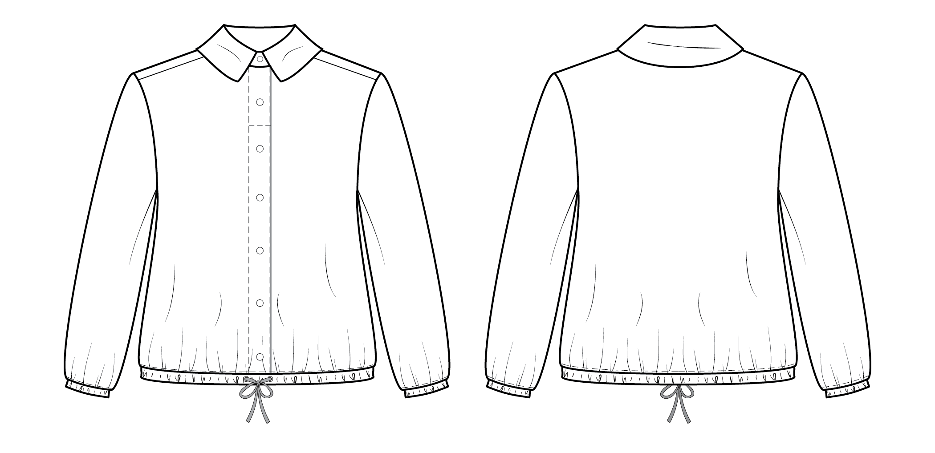
Note. Technical sketch of garment in proportion to actual size created in Adobe Illustrator. Left: Front sketch. Right: Back sketch.

Figure A2
Gathered Faux Button-Up With 3/4 Sleeve Technical Drawing With Construction Callouts
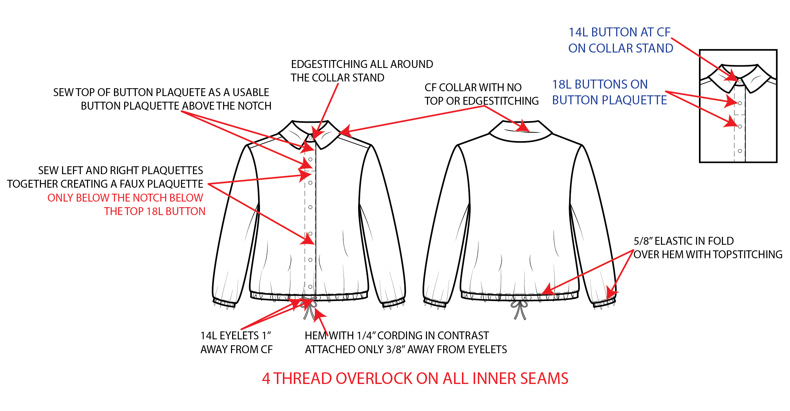
Note. Illustration of Figure A1 with garment and sewing callouts that will allow for proper construction of the garment. 14L = 14-ligne button size; 18L = 18-ligne button size; CF = center front.

Figure A3
Gathered Faux Button-Up With 3/4 Sleeve Colorways
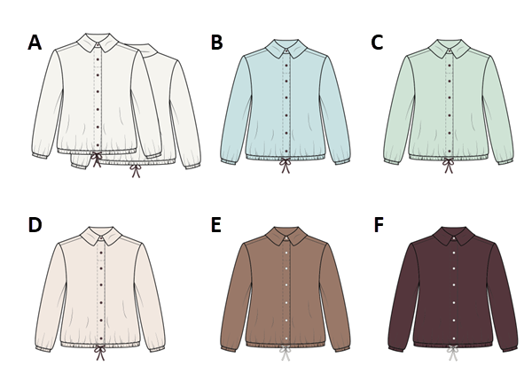
Note. Illustrations of Figure A1 in each Pantone color that will be offered. A: Pantone 11-0602 TCX (Snow White). B: Pantone 12-4604 TCX (Skylight). C: Pantone 12-5504 TCX (Clearly Aqua). D: Pantone 11-1302 TCX (Sea Salt). E: Pantone 17-1417 TCX (Beaver Fur). F: Pantone 19-1624 TCX (Sassafras).

Appendix B
Pattern and Fitting
Figure B1
Gathered Faux Button-Up With 3/4 Sleeve Pattern
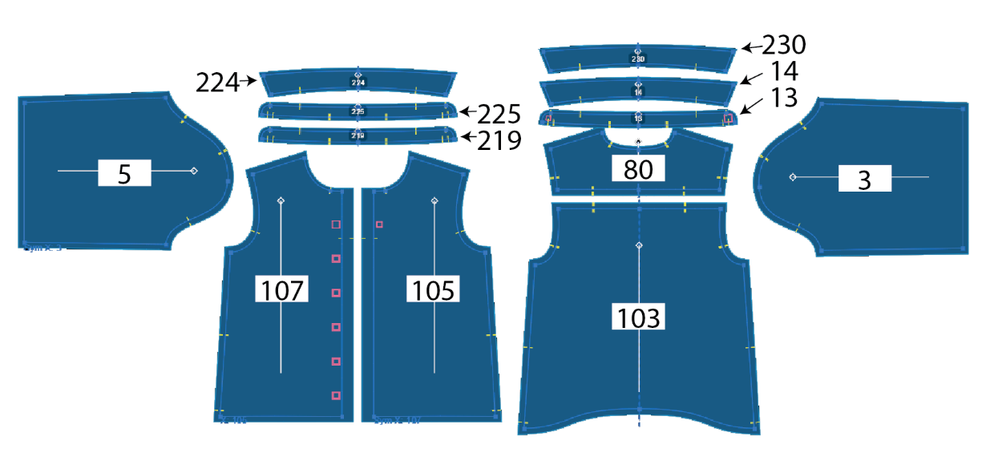
Note. Illustration of pattern made in Browzwear V-Stitcher that will be used to create the garment. 3 = right sleeve; 5 = left sleeve; 13 = outer collar stand; 14 = outer collar; 80 = yoke; 103 = back; 105 = front left; 107 = front right; 219 = inner collar stand; 224 = under collar; 225 = collar stand interfacing; 230 = collar interfacing.

Figure B2
Gathered Faux Button-Up With 3/4 Sleeve Virtual Fitting
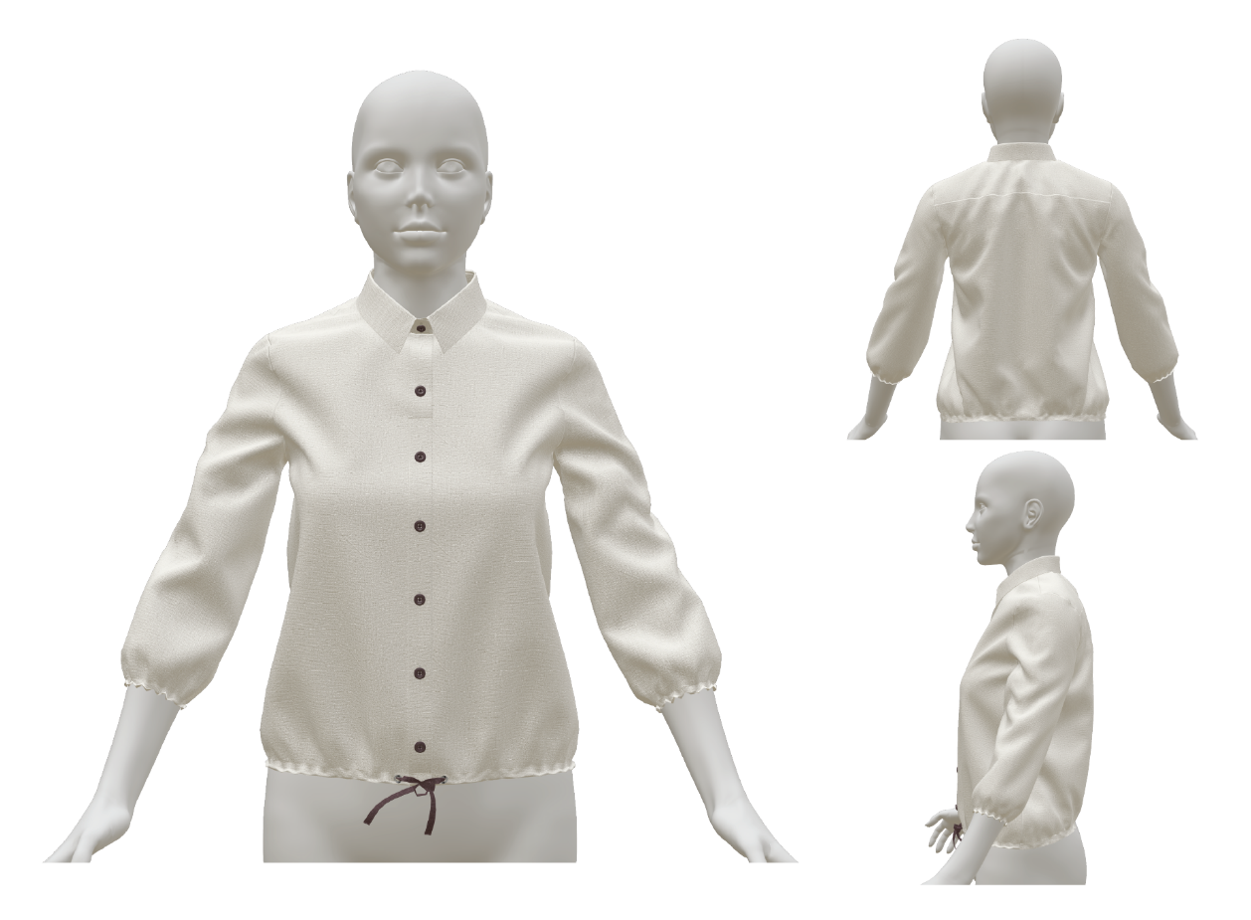
Note. Illustration of garment rendered on a virtual avatar in Browzwear V-Stitcher using the pattern from Figure B1.
Figure B3
Gathered Faux Button-Up With 3/4 Sleeve Fitting Maps
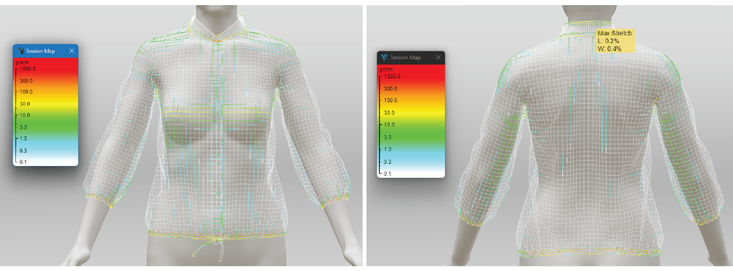
Note. Illustration of garment tension maps on a virtual avatar in Browzwear V-Stitcher using the pattern from Figure B1. White, blue, and green indicate areas of the garment that are loose or fit well, whereas yellow and red indicate areas that are tight and of possible concern in the fitting. These illustrations show that the garment fits loosely, other than where the elastic will be placed. Left: Tension levels for the front of the garment on the virtual avatar. Right: Tension levels for the back of the garment on the virtual avatar.

Appendix C
Bill of Materials: Simple
Description | Placement | Size | Color | Finish | Amount | Supplier | Content | Comment
Fabric and textiles
Linen | Self and lining |  | Snow White, Skylight, Clearly Aqua, Sea Salt, Beaver Fur, and Sassafras |  | Refer to pattern in Figure B1 | East Bay Depot | 100% linen | 138 GSM
Interfacing
Woven interfacing | Collar and collar stand |  | White | Fusible | Refer to pattern in Figure B1 | Permess International | Cotton
Notions and trims
Eyelet | Center front hem | 14L | Silver | Metallic | 2 | East Bay Depot | Metal
Elastic | Cuffs and hem | 5/8” | White |  | 36” | East Bay Depot | Elastane and nylon
Cording | Inner hem | 1/4” | Snow White, Skylight, Clearly Aqua, Sea Salt, Beaver Fur, and Sassafras |  | 48” | East Bay Depot | 100% cotton | Finished tip
Button 1 | Center front | 18L | Snow White, Skylight, Clearly Aqua, Sea Salt, Beaver Fur, and Sassafras |  | 6 | East Bay Depot
Button 2 | Collar stand | 14L | Snow White, Skylight, Clearly Aqua, Sea Salt, Beaver Fur, and Sassafras |  | 1 | East Bay Depot
Thread | All over |  | DTM self |  |  | East Bay Depot | 100% cotton
Labels and tags
Hangtag | Side seam and sleeve intersection | 3 × 1” | See hangtag artwork file |  |  | Dutch Label Shop | Paperboard
Care label | Inner center back neckline |  |  |  |  | Bay Thread | Cotton | Factory finish and complete
Size label | Over care label | 0.5 × 1” | See size label file |  |  | Dutch Label Shop | Cotton | Loop label
Brand label | Left side seam,  1” up | 0.5 × 0.5” | See brand label artwork file |  |  | Dutch Label Shop | Cotton
Packaging
Compostable mailer |  |  | See package artwork file |  |  | Tishwish |  | For individual garments
Tissue paper |  |  | White |  |  | Tishwish
Note. This table illustrates the materials and their specifications to complete the garment. The hangtag artwork, size label, brand label artwork, and package artwork files are provided in the supplemental materials. 14L = 14-ligne button size; 18L = 18-ligne button size; GSM = grams per square meter; DTM = dye to match.

